USB to High-Speed Parallel Port

Adapter Cable

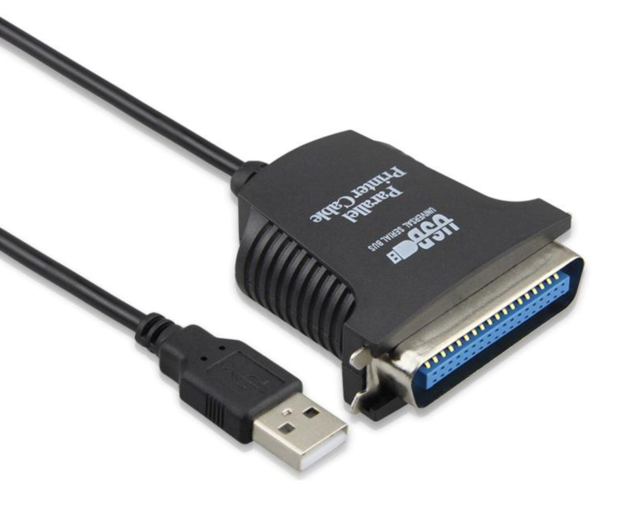

Fully compatible with legacy Parallel Port printers, scanners and more

High-speed Parallel 1284 compliance for total compatibility

USB Plug n' Play for easy installation for popular Operating Systems

Available USB port

CD-ROM/DVD drive (if required)

MicrosoftTM Windows2000TM,

Windows XPTM, Windows VistaTM

Windows7TM, Windows8TM

Windows10TM

Part number: USB-C-PP-1284
Barcode number: 840080005014
Weight: 0.200 kg

